Marathwada Shikshan Prasarak Mandal’s

**Deogiri Institute of Engineering and Management Studies,**

**Aurangabad**

**Seminar Report**

**Smart PVoting System With Face** **Recognition**

Submitted By

**Sonali pramod nare (36139)**

**Dr. BabasahebAmbedkar Technological University**

**Lonere (M.S.)**



Department of Computer Science and Engineering

**Deogiri Institute of Engineering and Management Studies,**

**Aurangabad**

(2019- 2020)

**Seminar Report**

**On**

**Smart PVoting System With Face recognition**

Submitted By

**Nare Sonali Pramod (36139)**

**In partial fulfillment of**

**Bachelor of Technology**

**(Computer Science & Engineering)**

Guided By

**Mr.Pankaj.H.Durole**

Department of Computer Science & Engineering

**Deogiri Institute of Engineering and Management Studies,**

**Aurangabad**

(2019- 2020)

**CERTIFICATE**

This is to certify that,the Seminar entitled “**Smart Voting System With Recognition**” submitted by **sonali pramod** **nare** is a bonafide work completed under my supervision and guidance in partial fulfillment for award of Bachelor of Technology (Computer Science and Engineering) Degree of Dr. BabasahebAmbedkar Technological University, Lonere.

Place: Aurangabad

Date:15-10-19

**Mr P.H. Durole Mr. S.B. Kalyankar**

**Guide Head**

**Dr. Ulhas D. Shiurkar**

**Director,**

**Deogiri Institute of Engineering and Management Studies,**

**Aurangabad**

**Abstract**

In this paper a new authenticatsion technique in online voting system using facial recognition of the voter is used. In India, currently there are two types of voting system in practice. They are secret Ballet paper and Electronic Voting Machines (EVM), but both of the process have some limitation or demerits. In India online voting has not been yet implemented. The current voting system is not safe and secure too. The voters need to go to distributed places like polling booths and stand in a long queue to cast their vote, because of these reasons most of the people misses their chance of voting. The voter who is not eligible can also cast its vote by fake means which may leads to many problems. That’s why in this project we have to propose a system or way for voting which is very effective or useful in voting. In our approach we have three level of security in voting process.

The first level is the verification of unique id number (UID), second level is the verification of election id number (EID) and third level is face recognition or face matching. The security level of our system is greatly improved by the new application method for each voter. The user authentication process of the system is improved by adding face recognition in an application which will identify whether the particular user is authenticated user or not.

###### 

###### 

###### Contents page no

**List of Figures i**

**List of Screens ii**

1. **INTRODUCTION 8** 
   1. Introduction
2. **LITERATURE SURVEY 10** 2.1 Literature Survey
3. **Brief on System**

3.1 Existing System 11

3.2 Proposed System 12

3.3 Image Processing 14

3.4 Output Result 17

1. **CONCLUSIONS 18** 4.1 Conclusion

5.**REFERENCES 19**

**6.ACKNOWLEDGEMENT s20**

**List of Figures**

**Figure Illustration Page**

3.1.1 Exiting Voting Process scenario. 11

3.2.2 Proposed framework architecture. 12

3.2.3 Working flow of the system. 13

3.2.4 Propound Voting Process Scenario. 14

3.3.5 Sequence of Image Processing Algorithm. 15

**List of Screen**

**Figure Illustration Page**

3.4.1 Output Result 17

**1.INTRODUCTION**

In India, currently we are having two kinds of voting mechanisms first the secret Ballet paper and the second one is Electronic Voting Machines (EVM), but the process of voting has some demerits and drawbacks, that is, why is the present ongoing system not so much safe & secure. In our chosen study of the system, we are proposing three levels of verification which is very effective in reducing the false voting scenarios. The first includes the unique id generate at the of registration which would be given to the voter. After which, in the second level of security when given id to the Election Commission Officer where it would be crosschecked by the officer and now the new tier of verification through which the voter needs to go, will greatly enhance the security, here we would be matching the current facial features of voter with the one present in database, this would reduce the chances of false casting of voting and make the system safer and accurate. In this paper, we will discuss the different types of algorithms used in the field of facial recognition. Along with this, we will also make a comparison between these algorithms. We have also measured the accuracy of these algorithms by practically implementing it and evaluating it on the test set.

In the development of any country democracy plays a vital role. Democracy System runs by a leader of the country who is selected by citizen of a country. Citizens have right to choose leader through election. Process of election consumes lots of man-power as well as resources and preparation is started many days before commencement of the election. During this preparation it may happen that involved people make an illegal arrangement with each other or try to substitute their henchmen in this process to win the election. Election is the system which gives people a chance to choose their leader, so it must be transparent, Meddle-Proof, Usable, Authenticated, Accurate, Verifiability and Mobility. In the existing system there are certain drawbacks such as damage of machines, chances of violence, dummy voting and problem of proper monitoring is also an issue. As this process is place oriented and there is region wise distribution, voters need to reach the place of voting. This paper projects to implement voting system through mobile device within secure and violence free environment. The data storage format is encrypted which provides highly secured environment and is validated through face recognition.

The election is a well-known thing in modern days of Democracy. Electronic online voting over the Internet would be much more profitable. Many voters would appreciate the possibility of voting from anywhere. This paper proposes a people who have citizenship of India and whose age is above 18 years of age and any sex can give his\her vote online without going to any polling station. There is a database which is maintained in which all the names of voter’s complete information is stored.

There are some basic security requirements that need to be fulfilled by any voting system. These are: firstly, the anonymity of a voter’s ballot must be preserved, and voters must not be able to prove how they have voted; secondly, the voting system must be tamper-resistant to a wide range of attacks; thirdly, a voting system must be user-friendly. In addition, voting process must be transparent and comprehensible enough so that voters and candidates can readily accept the results. In general, such online voting should satisfy such requirements as follows:

1. Accuracy

2. Simplicity

3.Verifiability

4. Democracy. Privacy

6. Security

For such an online voting system, security and privacy are the main concerns. From that point of view, an implementation of the online voting system appears with face recognition and password (OTP). Our approach suggests a practical application of the existing face recognition and password (OTP) that ensures the integrity of the vote cast by voter and authentication of the voter at the two levels. The advantage of the online voting system is that voter can vote from anywhere through the internet. Subsequently, the result of the election is computed from the sum of the votes which have been voted by the voters.

**2. LITERATURE SURVEY**

The past work done in this domain involves reviewing the already present algorithms and comparison for these algorithms based on various features and conditions such as the kind of database used, and neural network-based image processing system used for the identification of the facial features . The amount of distortion and attenuation plays a big role in generating a clear and transparent image in a localized area of the image frequency as it would be important aspect while capturing the image and processing of it to accurately match it with one that is present in the database.

Deutsch proposed voting system based on Punch-card and mark-sense optical scan systems as well as DRE. It does not include any biometric security. After that many secure voting systems have been proposed. process of voting starts with the card punching and the real process of online voting through ATM terminal. It ensures duplicate vote avoidance through dual-tier authentication using One Time Password (OTP) and a Random Security Question (RSQ). Jambhulkar et.al and Mursi et.al.proposed Cryptographic schemes and a digital signature that ensures the integrity of the vote cast by voter and authentication of the voter.Malkawi et.al. , Sridharan and Anandaraj et.al. proposed e-voting system using simple biometrics for election process.Katiyar et.al. proposed an online voting system using steganography. It uses images as cover objects for steganography and as keys for cryptography. The steganography is to hide the information imperceptibly into a cover, so that the presence of hidden data cannot be diagnosed. Nazatul et.al. the scheme uses Fuzzy Extractor to provide biometric based authentication, while cryptography for the secret password which is used to provide password-based protection of the voter.

This paper proposes an online voting system scheme using face recognition and password (OTP) for security purpose. To the best of our knowledge, this is the first work that integrates face recognition with OTP for the online voting system. The noteworthy features of the proposed scheme can be summarized as follows:

* It fulfils the security requirements of a traditional voting system and brings the flexibility of the online voting system.
* It can use face recognition and OTP to authenticate the voters.

**3. BRIEF OF SYSTEM**

3.1 EXISTING SYSTEM:

In the current voting system, the ballet machines where used in which the symbols of various political parties are displayed .When we press the button with the respective party’s (political party) symbol the voting is done. The chance of fake person casting their vote is more in the existing system. The voting person may use the fake voting card and cast his vote, this may cause problem. In the existing system, the person has to travel long places to his constituency to cast his vote. Therefore, we need an effective method to identify the fake voters during voting. So, the process is used for detecting the right person and also making the system to work in online, which will help the voters to cast their vote from their place itself.

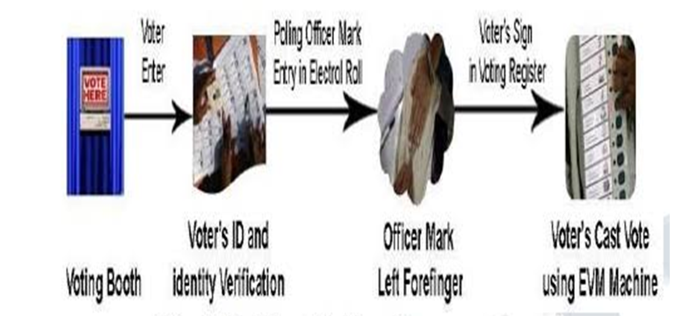

Fig no.3.1.1 Exiting Voting Process scenario

PROBLEM WITH EXISTING POLLING SYSTEM**:**

Allocation of location is decided in advance. Voters have to reach there to cast a vote. Chances of dummy voting are more because if authorized person is not honest as he/she is required to be so, he might perform illegal task of voting for a particular party person. Due to this malfunctioning chances of violence may raise or disturb the ongoing process . In few cases voter is registered at more than one area so there are chances of vote recorded twice. Different voters have different reason to deny or to avoid or to escape from the voting say, due to unavailability on the day or place of the voting, fear of violence. To execute a voting process man power is required and the cost will increase per election as the population increases

3.2 PROPOSED SYSTEM:

In this project we are working with three different security levels

Level1: -Unique id number (UID). At the time of voter registration system will request for the unique id from the voter. The entered unique id is verified from the database provide by the election commission.

Level2: Election commission ID card number. In the second level of verification, the voter has to enter the election commission id or voter’s id number. The entered id number is verified from the database provide by the election commission.

Level3: - Face recognition with respective election commission id number. In this level, Eigen face algorithm is used to verify the facial image of the voters from the database provided by the election commission.

PROPOSED FRAMEWORK ARCHITECTURE:

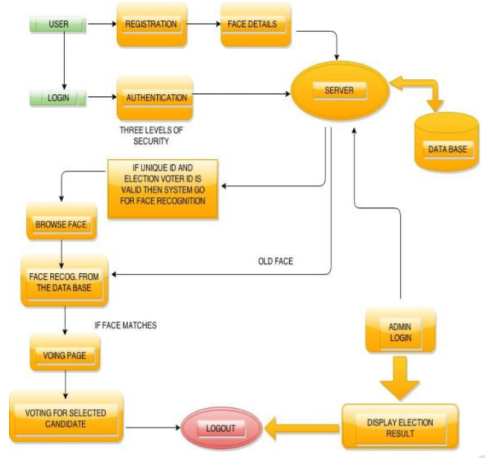

Fig no 3.2.2 Proposed framework architecture

1. Highly secured because in this project we have to use face recognition and face comparison. Tech. so false user can’t give votes.

2. We can access result (counting) faster than existing system Because ballet system takes much more time for counting process.

3. Online voting system increase voting percentage in India. Because lots of people don’t give vote they think that the voting process is to lengthy but in our approach any one can give vote from home easily.

Working Flow Of The Proposed System:

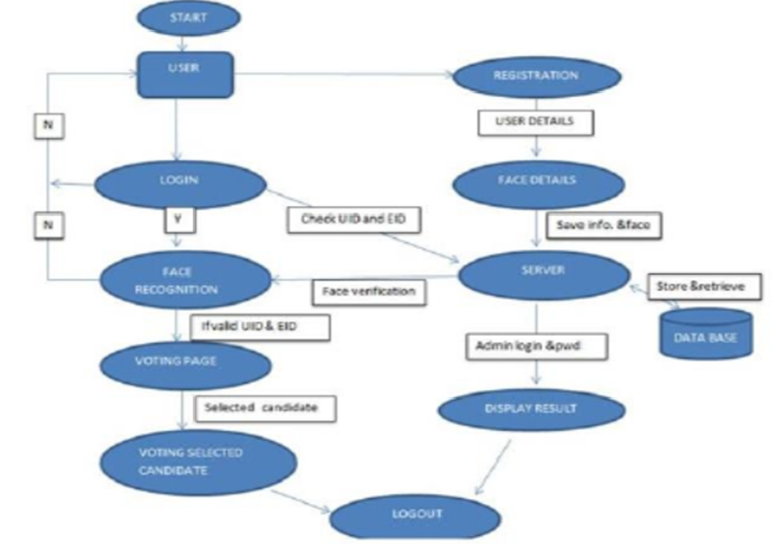

Fig no 3.2.3 Working flow of the system

i) Every New User in the India is first register for Voting. So, our first step is registration.

ii)At that time of Registration System Capture, the Face of the user by using Web Camera and Store the Face sample in the Server Database for Security Purpose.

iii) At the time of election, we will use three level of security first one is unique I verification second one is voter id verification third one is face recognition.

iv).System will be checking whatever unique id and voter id entered by the voter is correct or not.

v) If unique id or voter id is correct than system will take image of voter and compare with the respective image of database or server.

vi)If the image in database is matching with the captured image of the voter, then he/she is allowed to cast is vote.

vii) On the voting page all the party whatever party contest in the election symbols /buttons will be there. Voter can cast his /her vote in the election.

viii)As soon as voter will give vote the id of voter logout automatically so we can say that a voter can give only one vote.

ix)On counting form only election commission authorized user can login with the secure id and password if both id and password is correct then voting process will be continuing.

ADVANTAGES OF PROPOSED SYSTEM:

As in the proposed system everything is done through one device so, voting will become transparent to all citizens. There is no chance of violence or attack as this process is not place oriented. Voters do not need to wait for longer period of time as they do not have to wait in a queue and there is no time constraint; this system provides mobility for voters. Less time consuming as compared to existing system. As this system stores the counting centrally the result of election comes in short time period. Cost is reduced as the smart devices are available with the individuals. Also since no or very little man-power is utilized, the cost of process execution is reasonably reduced. Highly secure and no chances of data lost. Voting information will store at server so no need to worry if smart device will damage. Unlimited no. of candidate information is being stored. Data storage capacity is high.

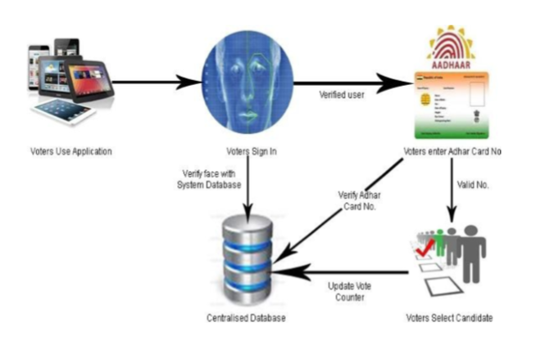

Fig no .3.2.4. Propound Voting Process Scenario

3.3 IMAGE PROCESSING:

In this system, face recognition is playing main role for authentication. Live image will be scaptured by mobile frontal camera. This captured image will be sent to the server for further processing. By using this image, server checks whether user is authorized or not. User is permitted for voting only if he is authorized.

There are many techniques to recognize face by using image processing. We are using some standard algorithms for face recognition. And they are Grayscale, Threshold, Blurring, Scaling, Template generation & matching.

These algorithms should process sequentially on image.

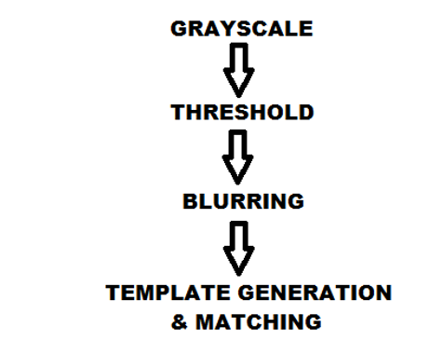

Fig no 3.3.5. Sequence of Image Processing Algorithm

A. Grayscale Algorithm

Grayscale images have many shades of gray in between. Grayscale images are also called monochromatic, denoting the absence of any chromatic variation (i.e., one color). In this system averaging method is used to grayscale the image. In averaging method, RGB values are separated from pixel and calculate the average value by using following formula,

GS = (R+G+B) / 3.

Where GS: Average value of Red, Green and Blue.

This GS value is replaced by original pixel value. By doing this we get the image in grayscale format.

B. Threshold Algorithm

Threshold is the simplest method of image segmentation. From a grayscale image, threshold can be used to create binary images.

During the threshold process, individual pixels in an image are marked as "object" pixels if their value is greater than some threshold value (assuming an object to be brighter than the background) and as "background" pixels otherwise.

This convention is known as threshold above. Variants include threshold below, which is opposite of threshold above; threshold inside, where a pixel is labeled "object" if its value is between two thresholds; and threshold outside, which is the opposite of threshold inside. Typically, an object pixel is given a value of “1” while a background pixel is given a value of “0.” Finally, a binary image is created by coloring each pixel white or black, depending on a pixel's labels.

The key parameter in the threshold process is the choice of the threshold value. Several different methods for choosing a threshold exist; users can manually choose a threshold value, or a threshold algorithm can compute a value automatically, which is known as automatic threshold. A simple method would be to choose the mean or median value, the rationale being that if the object pixels are brighter than the background, they should also be brighter than the average.

C. Blurring Algorithm

In image terms blurring means that each pixel in the source image gets spread over and mixed into surrounding pixels. Another way to look at this is that each pixel in the destination image is made up out of a mixture of surrounding pixels from the source image. Smart Voting System with face recognisition.

Blurring an image reduces the sharpening effect; this makes the detection more accurate. We are doing blur by calculating the average of surrounding 8 pixels that is 3*3 windows. To increase the blur effect we can scan surrounding 5 pixels that is 5*5 windows.

D. Scaling Algorithm

Image scaling is the process of resizing a digital image. Scaling is a non-trivial process that involves a trade-off between efficiency, smoothness and sharpness. Image is scaled into some standard size by using different scaling methods.

E. Template Generation & Matching

Template matching is a technique in digital image processing for finding small parts of an image which match a template image. It can be used in manufacturing as a part of quality control, a way to navigate a mobile robot, or as a way to detect edges in images. Template matching can be subdivided between two approaches: feature-based and template-based matching.

The feature-based approach uses the features of the search and template image, such as edges or corners, as the primary match-measuring metrics to find the best matching location of the template in the source image.

The template-based, or global, approach uses the entire template, with generally a sum-comparing metric(using SAD, SSD, cross-correlation, etc.) that determines the best location by testing all or a sample of the viable test locations within the search image that the template image may match up to. Improvements can be made to the matching method by using more than one template; these other templates can have different scales and rotations. It is also possible to improve the accuracy of the matching method by hybridizing the feature-based and template-based approaches. Naturally, this requires that the search and template images have features that are apparent enough to support feature matching.

3.4 OUTPUT RESULTS:

The proposed system will be beneficial in a number of ways. The voter verification will be done through face recognition. Only the verified voter can vote, hence dummy voting will be eliminated. A voter can vote only once. So, voting multiple times or dummy voting shall be prohibited. Moreover, being a smart device, there is no geographical and time constraint. The proposed system would limit the voting time period allowing the voters to vote within that time frame only. As there will be no crowd accumulation, there are no chances of violence. Being automated system, election in different slots need not be arranged. It can be organized on the same day all over the country. The voting result can be generated automatically and quickly. Also very less resources and man power will be utilized for execution of the system that will lead to overall reduction in cost. The proposed system is non-interfering, centralized, and economic as well time centric.

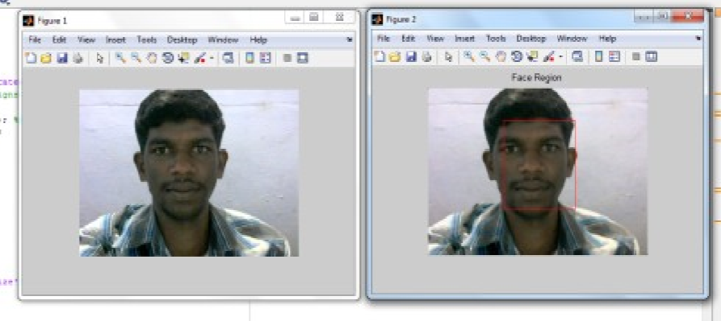

Screenshot 3.4.1

**4. CONCLUSIONS**

4.1 conclusion

Face recognition has been since its advent a more secure and trustworthy form of authentication by including this feature with our present voting system we could enhance the capabilities of the system and can make it more secure and free from false voting. In this paper, we have provided a comparative study based on the properties of the three types of algorithms, that is, Eigenfaces , Fisherfaces, and SURF (Speeded Up Robust Features). Along with this, we have also compared their performance based on how they classify faces in the images. Our training set consisted of 2316 images. The images in the training set were augmented for further enhancement of their features. Each augments set constituted of 4 more samples per image. So the complete set constituted of 2316*4, that is, 9264 images. On the basis of our research, we observed that the accuracy of the algorithms based on the training data came out to be, 77% for Eigenface algorithm, 80% for Fisherface algorithm and 88% for SURF algorithm. The training data consisted of 2316 labeled image. Apart from this, we observed another conclusion that the SURF algorithm only gives higher accuracy when the image has some similar features in comparison to the training data. In future work, we plan on increasing the training dataset and applying other important techniques like SIFT, deep learning neural network, etc.

**REFERENCE**

* <https://www.researchgate.net/publication/331224426_Smart_Voting_System_Support_through_Face_Recognition>
* <http://ijercse.com/specissue/aprilissue/36.pdf>.
* <https://www.isroset.org/journal/IJSRCSE/full_paper_view.php?paper_id=1266>

**ACKNOWLEDGEMENT**

I would like to place on record my deep sense of gratitude to Prof. S.B.kalynkar sir, HOD-Dept. of Computer Science and Engineering, Deogiri Institute of Engineering and management Studies Aurangabad , for his generous guidance, help and useful suggestions.

I express my sincere gratitude to Prof. P.H.Durole, Dept. of Computer Science and Engineering, Deogiri Institute of Engineering and management Studies Aurangabad, for his stimulating guidance, continuous encouragement and supervision throughout the course of present work.

I am extremely thankful to Ulhas Shiurkar, Director, Deogiri Institute of Engineering and management Studies Aurangabad, for providing me infrastructural facilities to work in, without which this work would not have been possible.

**Signature of Student**

Nare Sonali Pramod Sign